HANOI UNIVERSITY OF SCIENCE AND TECHNOLOGY

School of Information and communications technology

Software Design Document

Version 1.0

**EcoBikeRental**

Subject: Software Development

Group 8:

Trần Thị Hằng - 20176748

Dương Thị Huê - 20176772

Đỗ Minh Thông - 20176881

Phạm Nhật Linh – 20184285

*Hanoi, November 2020*

Table of Contents

Table of Contents 1

1 Introduction 4

1.1 Objective 4

1.2 Scope 4

1.3 Glossary 4

1.4 References 5

2 Overall Description 6

2.1 General Overview 6

2.2 Assumptions/Constraints/Risks 7

2.2.1 Assumptions 7

2.2.2 Constraints 7

2.2.3 Risks 7

3 System Architecture and Architecture Design 4

3.1 Architectural Patterns 8

3.2 Interaction Diagrams 8

3.3 Analysis Class Diagrams 13

3.4 Unified Analysis Class Diagram 16

3.5 Security Software Architecture 16

4 Detailed Design 17

4.1 User Interface Design 17

4.1.1 Screen Configuration Standardization 17

4.1.2 Screen Transition Diagrams 18

4.1.3 Screen Specifications 19

4.2 Data Modeling 29

4.2.1 Conceptual Data Modeling 29

4.2.2 Database Design 30

4.3 Non-Database Management System Files 37

4.4 Class Design 37

4.4.1 General Class Diagram 37

4.4.2 Class Diagrams 37

4.4.3 Class Design 38

5 Design Considerations 60

5.1 Goals and Guidelines 60

5.2 Architectural Strategies 60

5.3 Coupling and Cohesion 60

5.4 Design Principles 60

5.5 Design Patterns 60

**List of Figures**

Fig 1. General Use Case Diagram 6

Fig 2. Communication Diagram for Deduct money from card 8

Fig 3. Communication Diagram for Return Bike 9

Fig 4. Communication Diagram for Rent Bike 9

Fig 5. Communication Diagram for Select Dock marker 10

Fig 6. Communication Diagram for View Bike or Station information 10

Fig 7. Sequence Diagram for Deduct money from card 11

Fig 8. Sequence Diagram for Return Bike 11

Fig 9. Sequence Diagram for Rent Bike 12

Fig 10. Sequence Diagram for Select Dock marker 12

Fig 11. Sequence Diagram for View Bike or Station information 13

Fig 12. Analysis Class Diagram for Deduct money from card 13

Fig 13. Analysis Class Diagram for Return Bike 14

Fig 14. Analysis Class Diagram for View Bike or Station information 14

Fig 15. Analysis Class Diagram for Rent Bike 15

Fig 16. Analysis Class Diagram for Select Dock marker 15

Fig 17. Unified Analysis Class Diagram 16

**List of Tables**

No table of figures entries found.

# Introduction

## Objective

This SDD is written for the purpose of giving the audience a clear view about the design of the software. The document’s intended audience is anyone who is interested in designing software.

## Scope

1.2.1 Product name: **EcoBikeRental Software (Eco-Bike-Rental is how we read)**

1.2.2 Explain:

The software is for users to rent and return bikes automatically. EcoBikeRental is a 24/7 platform-independent system which allows novice users to user without any training. User must have an account to use the system. The software allows user to enter barcode or directly choose bike to rent and choose any bike station to return bike, use credit card for payment, and show detailed information of station and bike.

1.2.3 Application:

Nowadays, the need for using bike is higher than ever. Using bike is not only environmentally friendly, but also a very effective way of exercising. The main drawback of this need is that not everyone has a bike, or has any intention of buying one. How about renting public bike for a relative cheap price? Introduce to our software. EcoBikeRental provides a quick and convenience way to rent bike. It helps to reduce employees, saves money and time, and very convenience. It is very easy to use. With a lot of stations and bikes available, it satisfies the need of bike rental service especially in Eco Park Township.

## Glossary

We assume that the reader of this document has relatively good base knowledge about computer/software in general. Still, the document will be written in general-audience-friendly way that most reader can understand. Scholarly terms, if any, in this document will be briefly explained after it has been used.

## References

Centers for Medicare & Medicaid Services. (n.d.). *System Design Document Template.* Retrieved from Centers for Medicare & Medicaid Services: https://www.cms.gov/Research-Statistics-Data-and-Systems/CMS-Information-Technology/XLC/Downloads/SystemDesignDocument.docx

# Overall Description

## General Overview

About the system, we have some characteristics that make the apps resemble e-commercial website/software: An interface for interacting with user; user request by clicking on the interface and then the request is processed by system controller; we have a database (remote) to store any kind of data; any data-related request or change will be queried in the database; the change in database is then reflected in the UI (user interface). As you can see, there are three main components in the system: the UI, controller and data model. We choose this software to be a desktop application. We choose the three-layer architecture to be our design approach. The design architecture helps to separate different components and better organize the codebase.

Here is a high-level diagram to help you understand the core of our design:

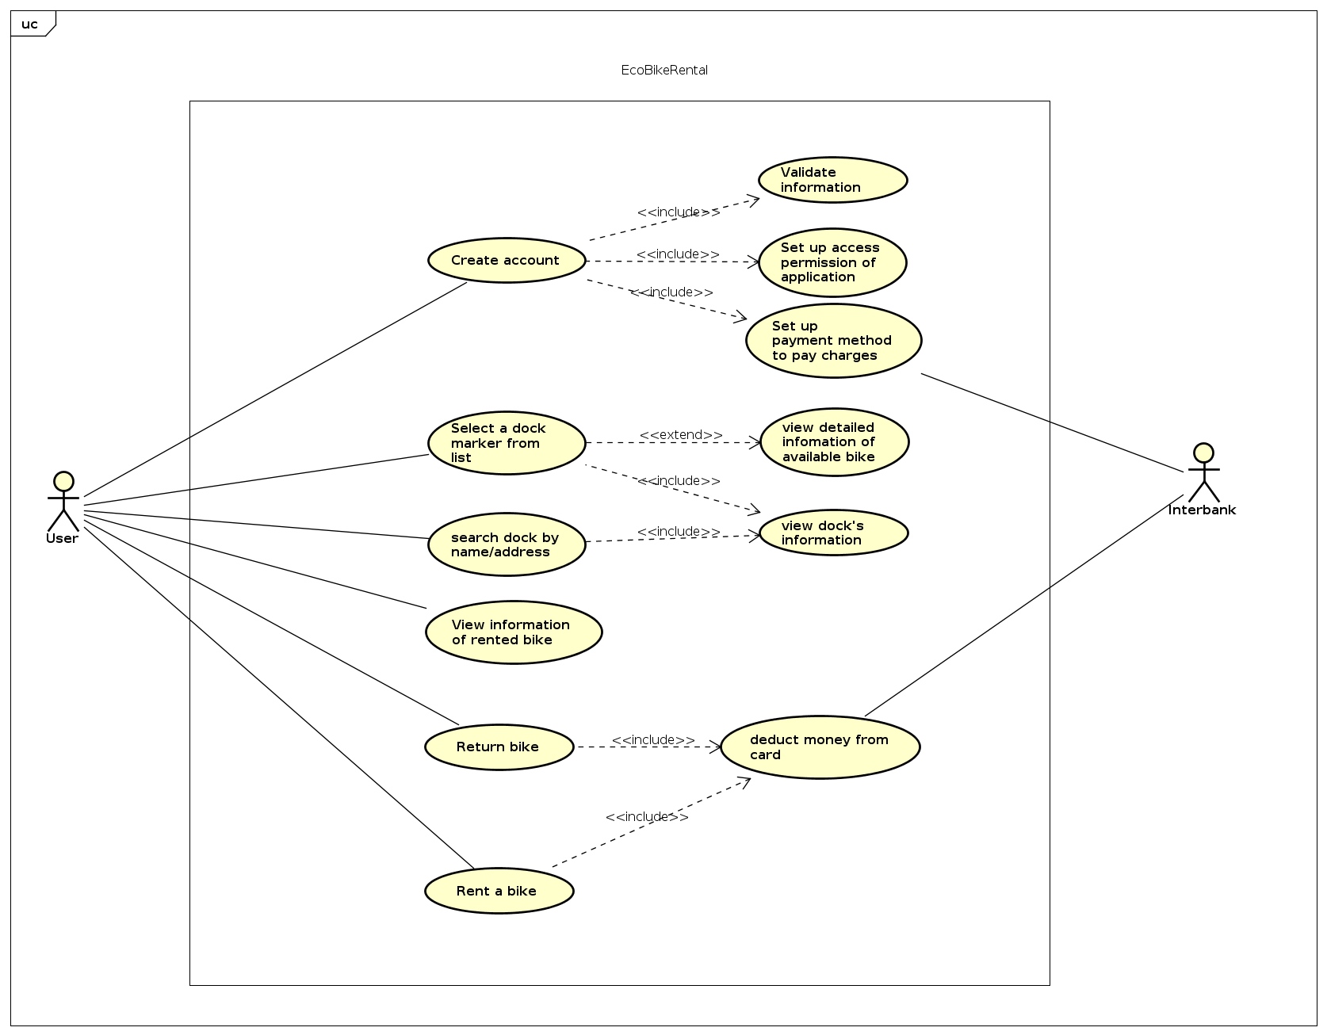

*Fig 1. General Use Case Diagram*

## Assumptions/Constraints/Risks

### Assumptions

User that use the software should have a good connection to the Internet. Also, our software is a desktop application, so the user also must have a laptop/desktop with an OS (we recommended 64 Bit Microsoft Windows 8 or later; macOS 10.13 or later; or any Linux distribution that supports running application) to run the apps. About the system requirement, we would say 2 GB RAM minimum, 8 GB RAM recommended; for storage 2.5 GB and another 1 GB for caches minimum, solid-state drive with at least 5 GB of free space recommended; require latest version of JRE; 1024×768 minimum screen resolution, 1920×1080 is a recommended screen resolution.

### Constraints

* Less than 2GB RAM; JRE version<8; Low storage may cause the software to run incorrectly, or cannot start running at all.
* Implicitly stated, ideally, the response time for any tasks, with a moderate load, within the system is 1 second. But in case of peak load, a response time in the interval of 2 seconds is admissible.
* Weak or no internet connection may cause the software to run improperly.

### Risks

* No risks to be discussed, yet.

# System Architecture and Architecture Design

Architecture Design steps:

1. Find out software components -> use cases
2. Find out Interaction between use cases
3. Find out Relationship between use cases
4. Draw UML Diagram includes: interaction diagram and analysis class diagram

## Architectural Patterns

In our project, we use 3-tier architectural pattern. There are many benefits of separating an application into tiers and the most important thing is it allows us to update a specific part of an application independently of the other parts

## Interaction Diagrams

**3.2.1. Communication Diagrams**

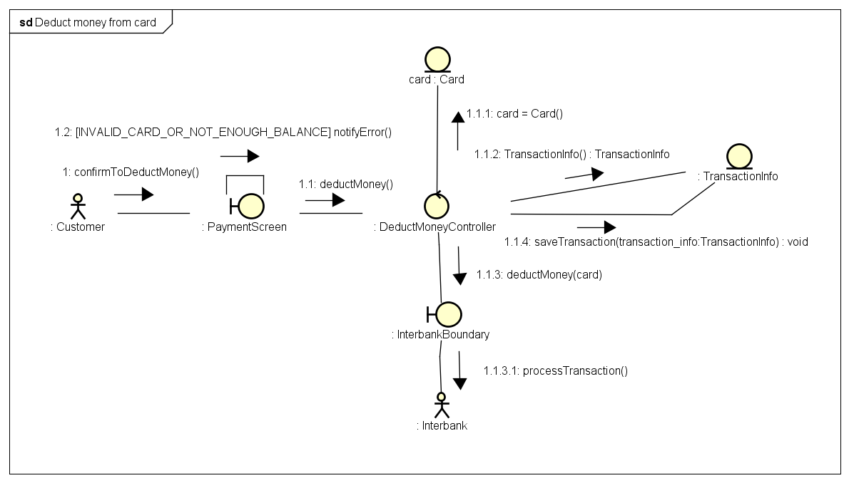

*Fig 2. Communication Diagram for Deduct money from card*

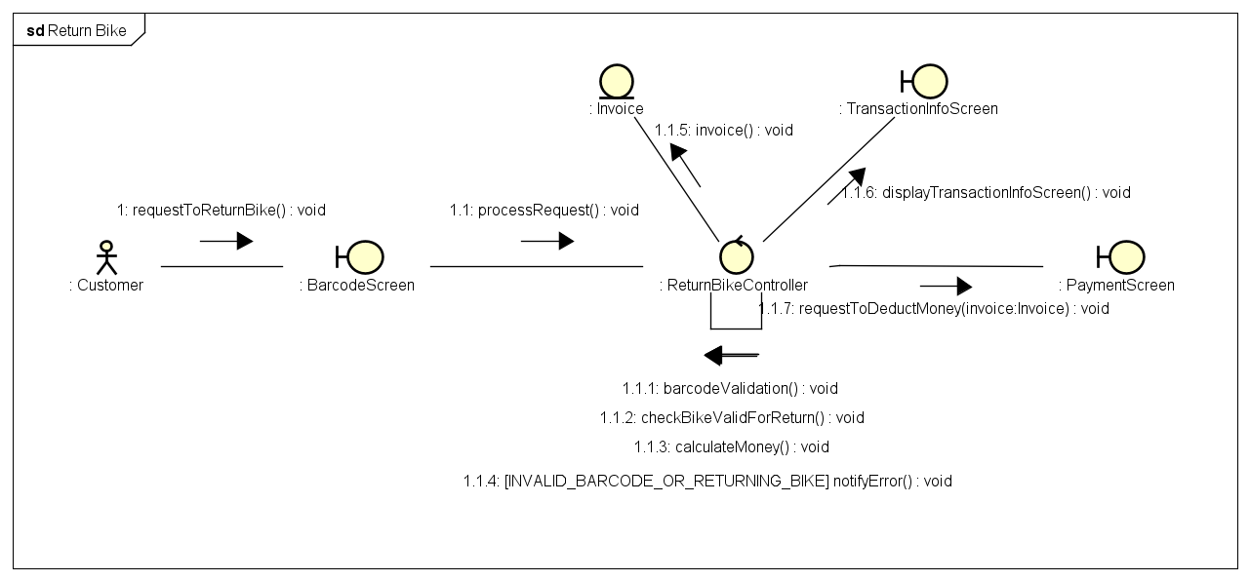

*Fig 3. Communication Diagram for Return Bike*

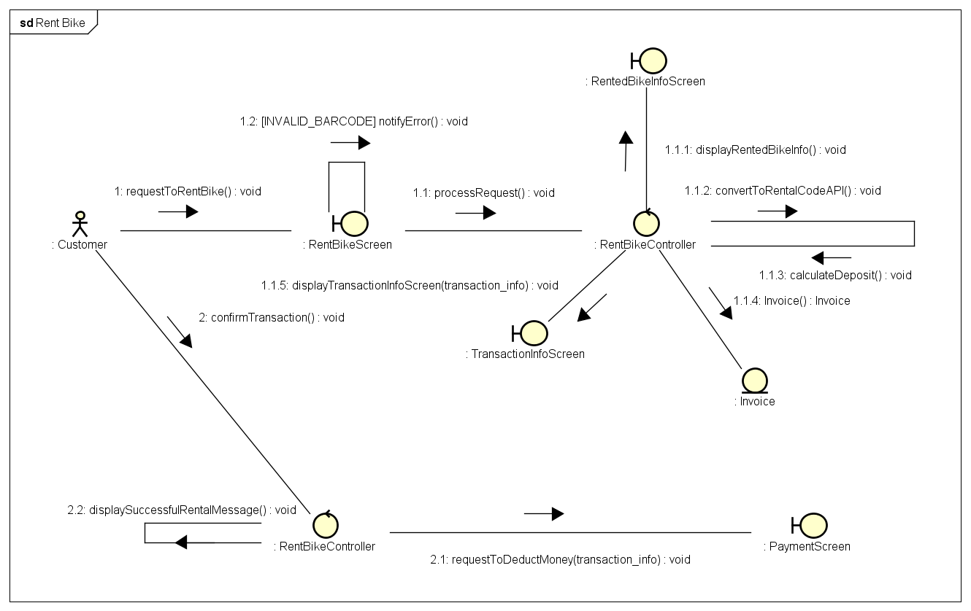

*Fig 4. Communication Diagram for Rent Bike*

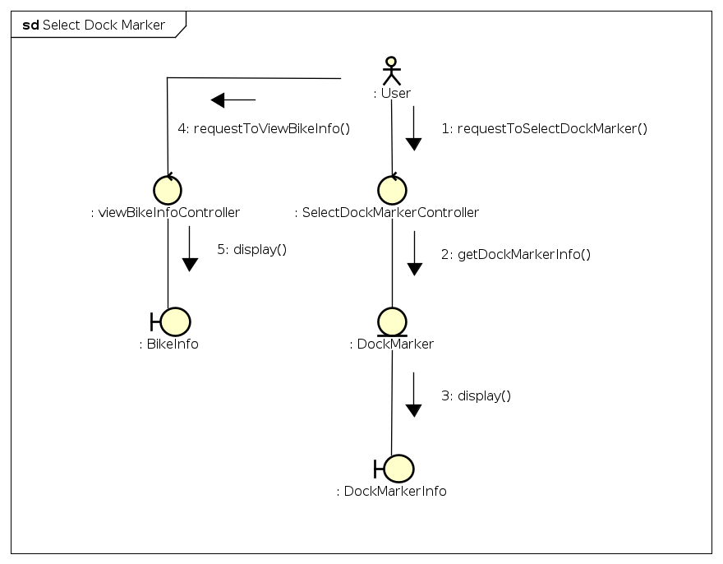

*Fig 5. Communication Diagram for Select Dock marker*

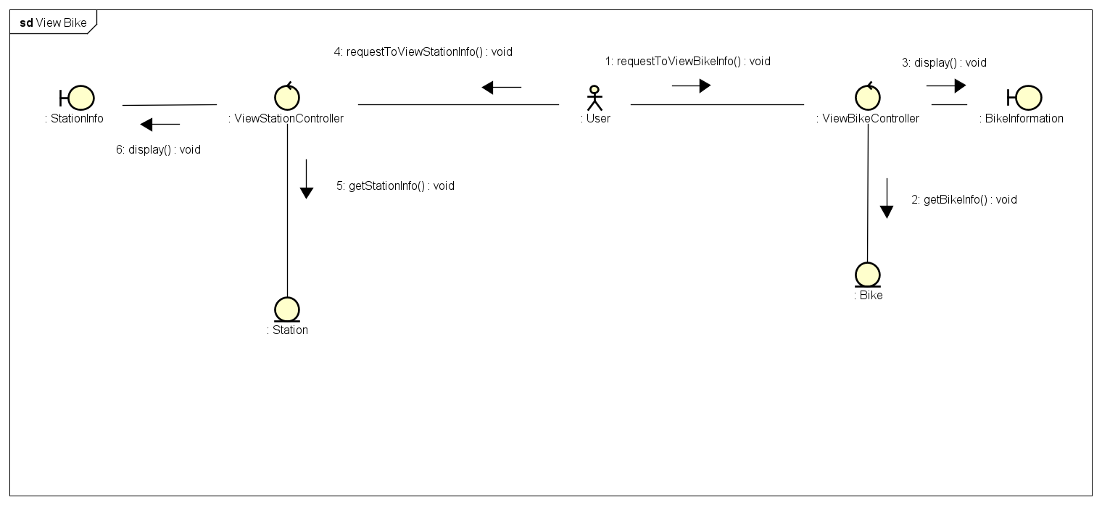

*Fig 6. Communication Diagram for View Bike or Station information*

* + 1. **Sequence Diagrams**

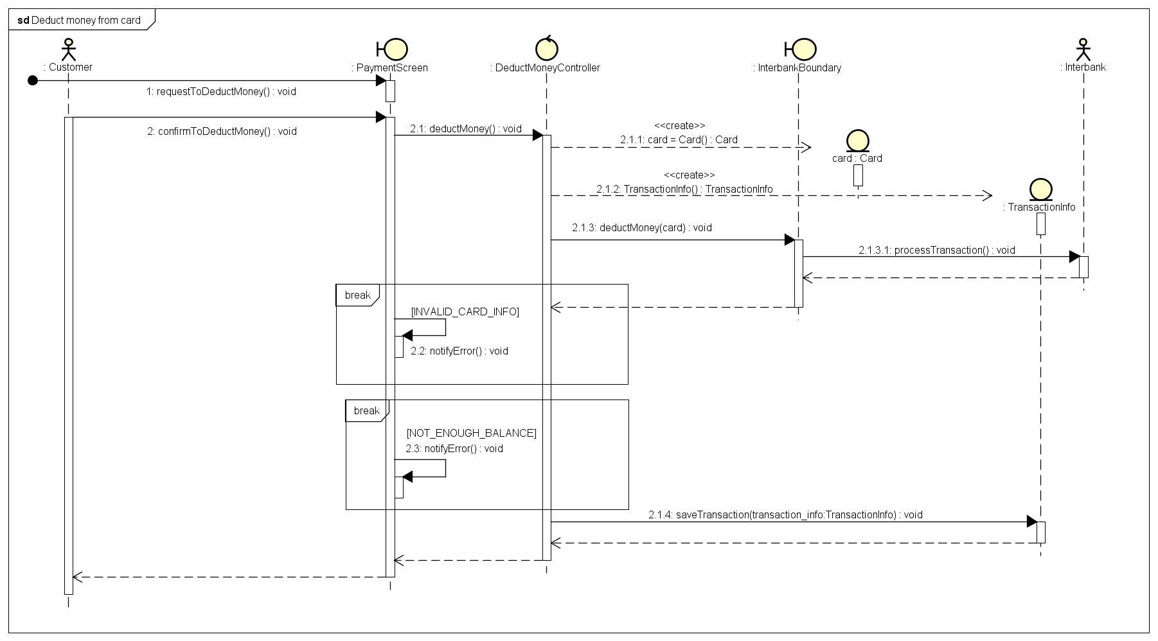

*Fig 7. Sequence Diagram for Deduct money from card*

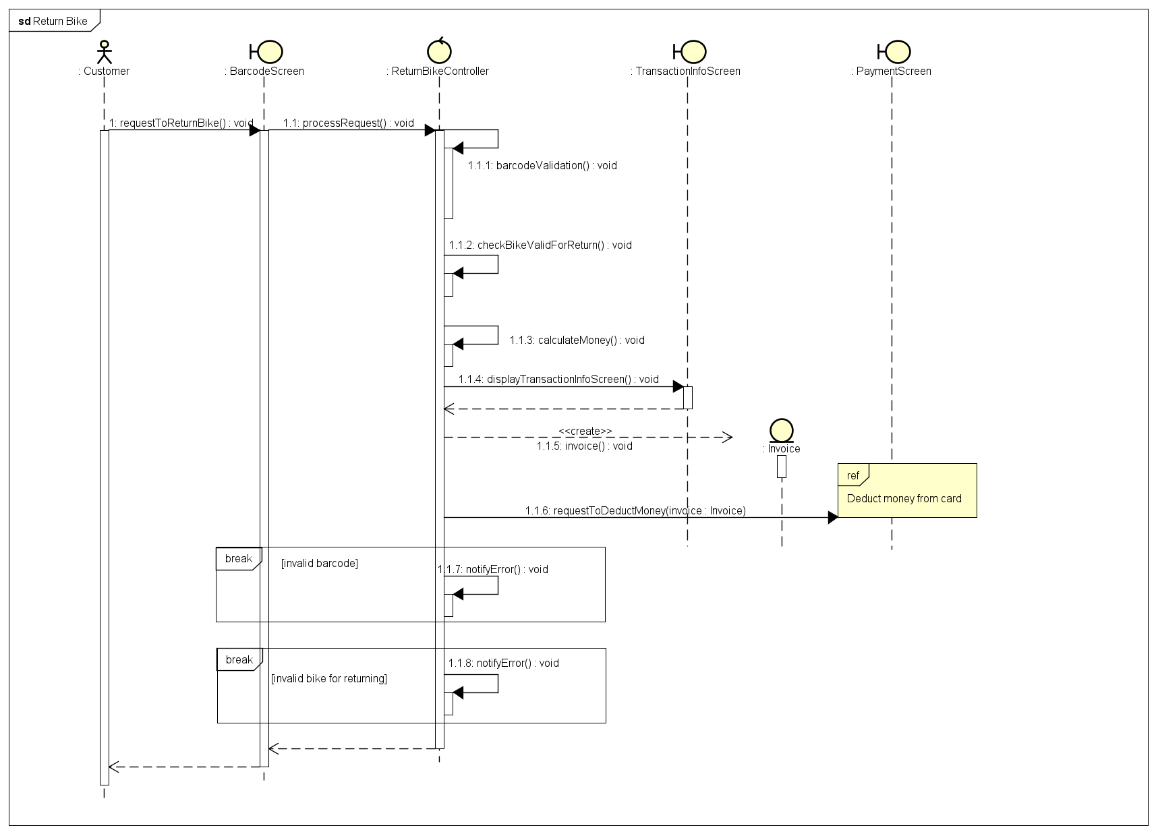

*Fig 8. Sequence Diagram for Return bike*

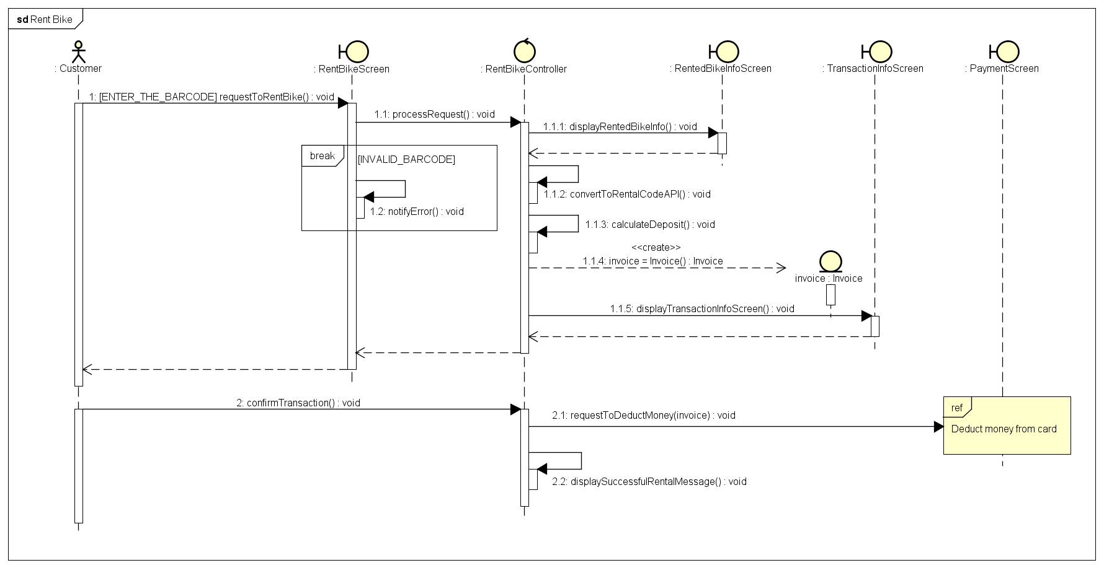

*Fig 9. Sequence Diagram for Rent bike*

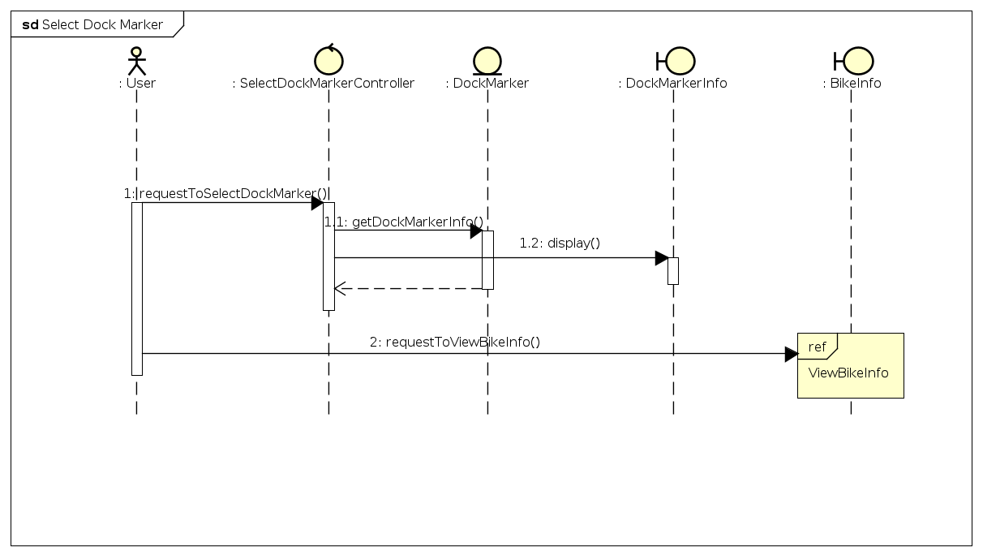

*Fig 10. Sequence Diagram for Select Dock marker*

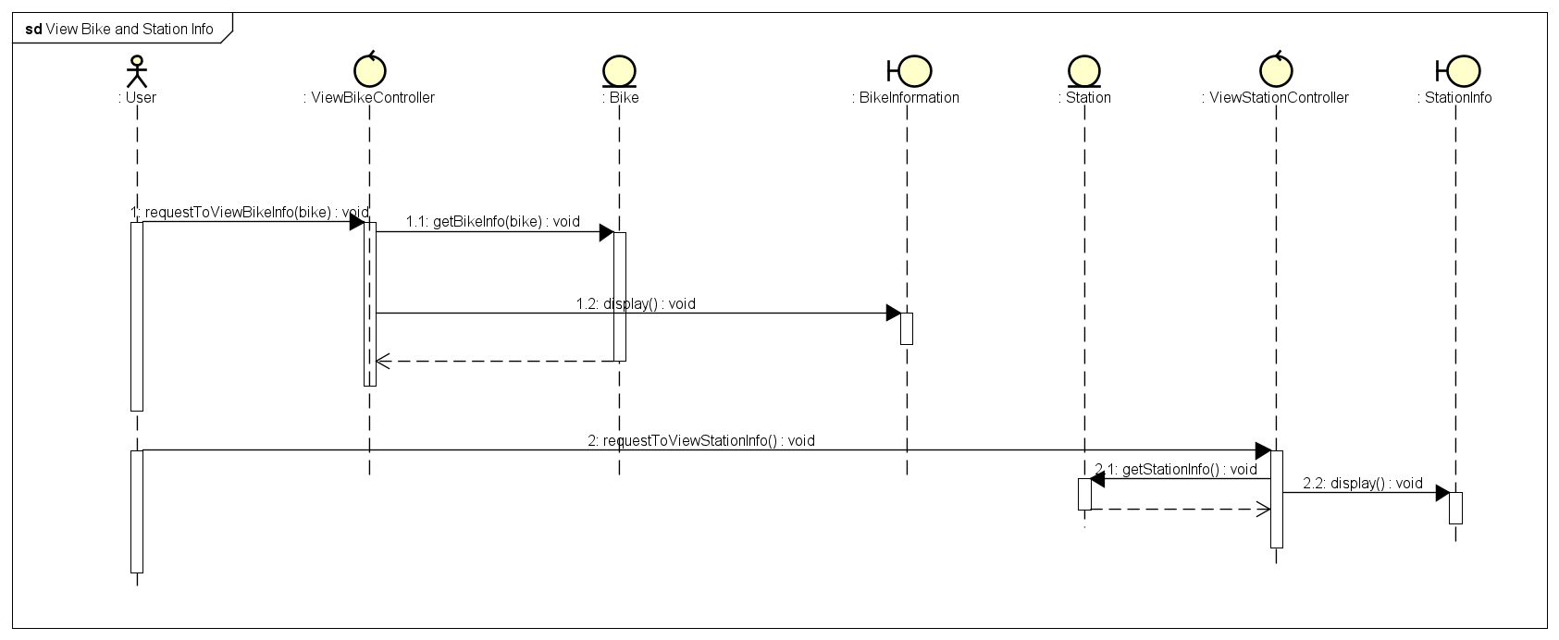

*Fig 11. Sequence Diagram for View Bike or Station information*

## Analysis Class Diagrams

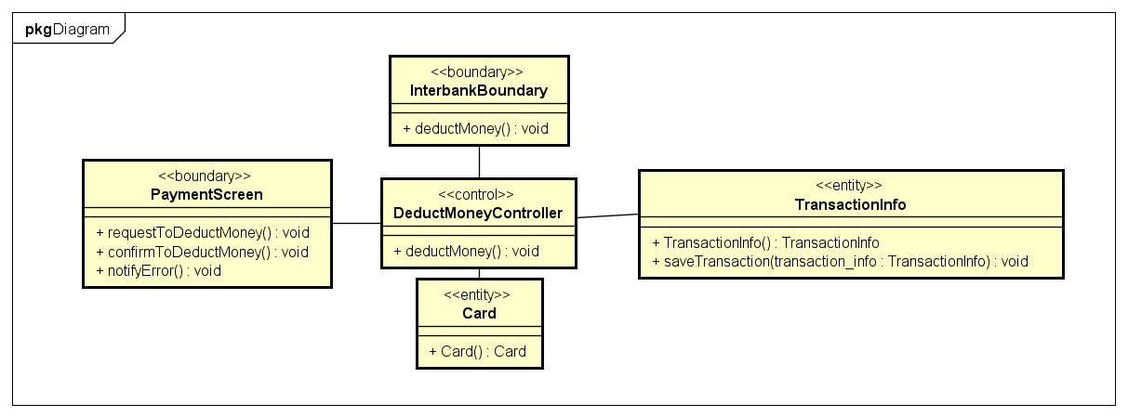

*Fig 12. Analysis Class Diagram for Deduct money from card*

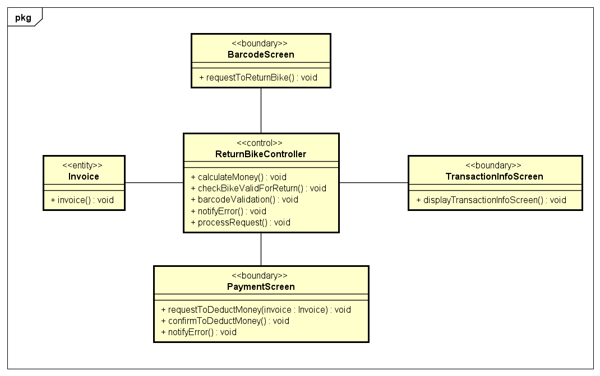

*Fig 13. Analysis Class Diagram for Return bike*

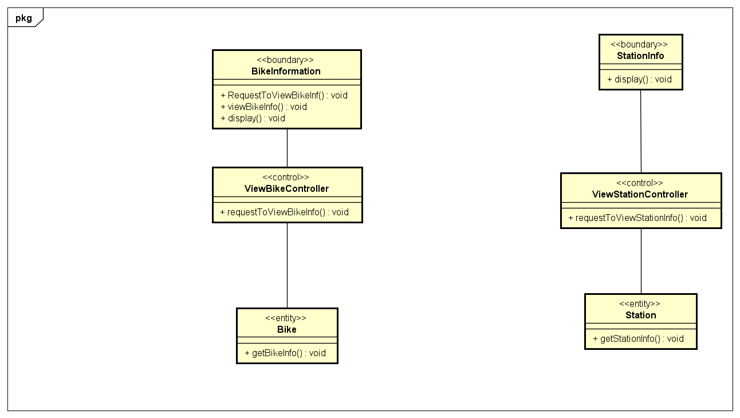

*Fig 14. Analysis Class Diagram for View Bike or Station information*

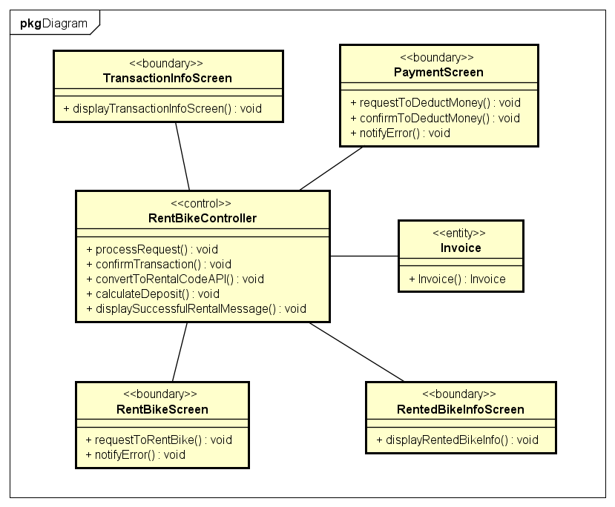

*Fig 15. Analysis Class Diagram for Rent bike*

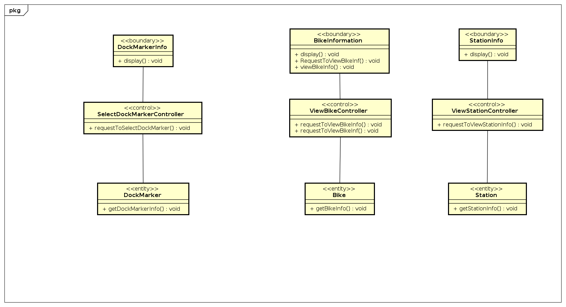

*Fig 16. Analysis Class Diagram for Select Dock marker*

## Unified Analysis Class Diagram

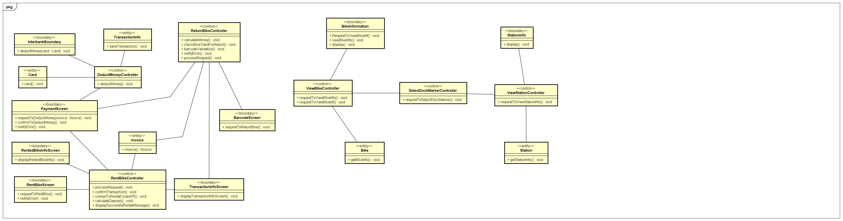

*Fig 17. Unified Analysis Class Diagram*

## Security Software Architecture

In this project, we will not consider features such as user authentication (e.g., sign up, sign in, sign out), but we focus on features related to bike renting and returning.

# Detailed Design

## User Interface Design

*<Suppose that you design a Graphical User Interface (GUI)>*

### Screen Configuration Standardization

**Display**

Number of colors supported: 16,777,216 colors

Resolution: 1366 × 768 pixels

**Screen**

- Location of standard buttons: At the bottom (vertically) and in the middle

(horizontally) of the frame

- Location of the messages: Starting from the top vertically and in the right horizontally of the frame down to the bottom.

- Display of the screen title: The title is located at the top of the frame in the middle.

- Consistency in expression of alphanumeric numbers: comma for separator of thousand while strings only consist of characters, digits, commas, dots, spaces, underscores, and hyphen symbol.

**Control**

- Size of the text: medium size (mostly 24px). Font: Arial. Color: # 201C1C

- Input check process: Should check if it is empty or not. Next, check if the input is in the correct format or not

- Sequence of moving the focus: There will be no stack frames. Each screen will be separated. However, the manual is considered a popup message, as the main screen cannot be operated while the manual screen is shown. After the opening screen, the app will start with splash screen, and then the first screen (home screen) will appear.

- Sequences of the system screens:

1. Splash screen (first screen)

2. Home screen

3. View Bike information screen – view information of a bike before renting

4. View Renting Bike information screen – view information of a renting bike

5. View Dock information screen – view information of a dock

6. View distance screen – view distance from user’s location to selected dock

7. Payment screen – fill payment information

8. Transaction Error screen – display detailed error of a transaction

9. Return Bike screen – display information to return a bike

10. Select Dock to return Bike screen – display list of docks to return a bike

11. Rent Bike screen – display detailed information for renting a bike

12. Invoice screen – display detailed invoice

13. Enter barcode screen – display a text area for entering barcode to rent bike

**Direct input from the keyboard**

There will be no shortcuts. There are back buttons to move back to the previous screen.

There is a Home button located at the top right of screen to go to Home screen.

Also, there are a close button “X” to close the screen, a resize button to resize screen and a minimize button “ _ “ to shrinks the window and places it on the taskbar while leaving the software running located at the title bar to the right.

**Error**

A message will be given to notify the users what is the problem.

### Screen Transition Diagrams

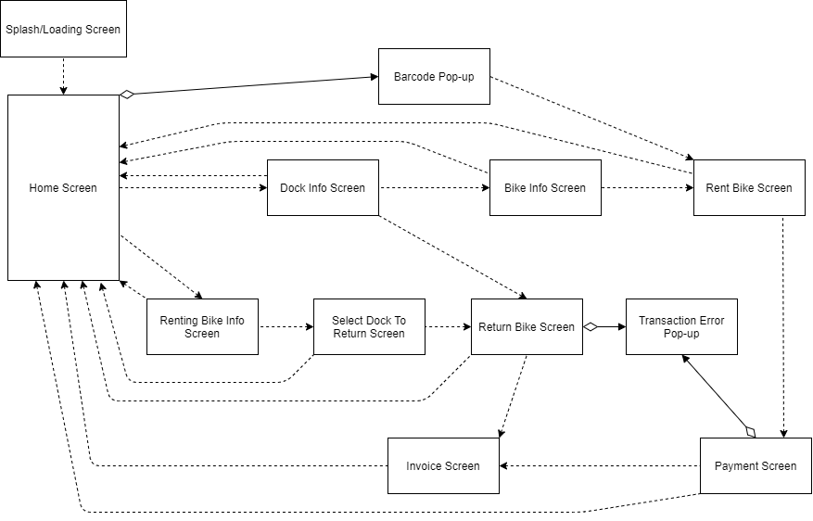

### Screen Specifications

***4.1.3.1. Return bike screen***

Screen specification

|  |  |  |  |  |  |
| --- | --- | --- | --- | --- | --- |
| EcoBikeRental Software | | Date of creation | Approved by | Reviewed by | Person in charge |
| Screen specification | Return Bike screen | 7/11/2020 |  |  | Trần Thị Hằng |
|  | | Control | Operation | Function | |
| Area for displaying Bike information | Initial | Display detail information of renting bike | |
| Area for displaying Card information | Initial | Display detail information of Card which will be used for payment | |
| Edit button | Click | Display the Payment Screen | |
| Cancel button | Click | Display Home Screen | |
|  |  | Submit button | Click | Display Invoice Screen/Transaction Error Screen | |

Defining the field attributes

|  |  |  |  |  |
| --- | --- | --- | --- | --- |
| Screen name | View cart |  |  |  |
| Item name | Number of digits (bytes) | Type | Field attribute | Remarks |
| Number Plate | 10 | String | Black | Left justified |
| Barcode | 6 | String | Black | Left justified |
| Type | 20 | String | Black | Left justified |
| Battery Percentage | 3 | Numeral | Black | Left justified |
| Remaining time | 2 | Numeral | Black | Left justified |
| Deposit | 10 | Numeral | Black | Left justified |
| Rented time | 5 | Numeral | Black | Left justified |
| Total | 20 | Numeral | Black | Left justified |
| Card holder | 50 | String | Black | Left justified |
| Card number | 20 | Numeral | Black | Left justified |
| Bank name | 20 | String | Black | Left justified |
| Expiration Date | 10 | String | Black | Left justified |
| Security Code | 10 | Numeral | Black | Left justified |

***4.1.3.2. Transaction Error Screen***

Screen specification

|  |  |  |  |  |  |
| --- | --- | --- | --- | --- | --- |
| EcoBikeRental Software | | Date of creation | Approved by | Reviewed by | Person in charge |
| Screen specification | Transaction Error Screen | 7/11/2020 |  |  | Trần Thị Hằng |
|  | | Control | Operation | Function | |
| Change Card Information button | Click | Display Payment Screen | |

***4.1.3.3. View Bike Information Screen***

Screen specification

|  |  |  |  |  |  |
| --- | --- | --- | --- | --- | --- |
| EcobikeRental Software | | Date of creation | Approved by | Reviewed by | Persion in charge |
| Screen specification | View bike information screen | 07/11/2020 |  |  | Dương Thị Huê |
|  | | Control | Operation | Function | |
| Area for  displaying the number plate | Initial | Display the number plate | |
| Area for display image of bike | Initial | Display image | |
|  |  | Area for display barcode | initial | Display the barcode | |
|  |  | Area for display remaining time | initial | Display remaining time of bike if it is electric bike | |
|  |  | Area for display battery percentage | initial | Display battery percentage of bike if it is electric bike | |
|  |  | Area for display deposit | initial | Display deposit | |
|  |  | Area coefficient price | initial | Display coefficient price to calculate amount | |
|  |  | Cancel button | Click | Back to station information screen | |
|  |  | Rent button | Click | Move to payment screen | |
|  |  | Home icon | Click | Back to home | |

Defining the field attributes

|  |  |  |  |  |
| --- | --- | --- | --- | --- |
| Screen name | View bike information screen |  |  |  |
| Item name | Number of digits (bytes) | Type | Field attribute | Remarks |
| Number plate | 8 | Numeral | Black | Left-justified |
| Barcode | 6 | Numeral | Black | Left justified |
| Type | 100 | Text | Black | Left-justified |
| Remaining time | 50 | Text | Black | Left-justified |
| Battery percentage | 4 | Text | Black | Left-justified |
| Deposit | 6 | Number | Black | Left-justified |
| Coefficient price | 3 | Number | Black | Left-justified |

***4.1.3.4. View Station Information Screen***

Screen specification

|  |  |  |  |  |  |
| --- | --- | --- | --- | --- | --- |
| EcobikeRental Software | | Date of creation | Approved by | Reviewed by | Persion in charge |
| Screen specification | View station information screen | 07/11/2020 |  |  | Dương Thị Huê |
|  | | Control | Operation | Function | |
| Area for  displaying the  Dock ‘s name | Initial | Display the name of dock | |
| Area for display dock ‘s address | Initial | Display dock ‘s address | |
|  |  | Area for display dock ‘s area | initial | Display the area of the dock | |
|  |  | Area for display number available bike | initial | Display remaining number available bike | |
|  |  | Area for display the number of empty docks | initial | Display number empty docks | |
|  |  | Area for walking time | initial | Display walking time from current user location to dock | |
|  |  | Area for display list available bike and its information | initial | Display list available bike in the dock and its information | |
|  |  | Home icon | Click | Back to home | |
|  |  | Rent button | Click | Move to payment screen | |

Defining the field attributes

|  |  |  |  |  |
| --- | --- | --- | --- | --- |
| Screen name | View bike information screen |  |  |  |
| Item name | Number of digits (bytes) | Type | Field attribute | Remarks |
| Number plate | 8 | Numeral | Black | Left-justified |
| Barcode | 6 | Numeral | Black | Left justified |
| Type | 100 | Text | Black | Left-justified |
| Remaining time | 50 | Text | Black | Left-justified |
| Battery percentage | 4 | Text | Black | Left-justified |
| Deposit | 6 | Number | Black | Left-justified |

***4.1.3.5. View Renting Bike Screen***

Screen specification

|  |  |  |  |  |  |
| --- | --- | --- | --- | --- | --- |
| EcobikeRental Software | | Date of creation | Approved by | Reviewed by | Persion in charge |
| Screen specification | View renting bike information screen | 07/11/2020 |  |  | Dương Thị Huê |
|  | | Control | Operation | Function | |
| Area for  displaying the bike information | Initial | Display bike information | |
| Area for display remaining time | Initial | Display remaining time of user | |
| Area for display  Renting time | initial | Display the renting time | |
| Area for display amount up to now | initial | Display amount to be paid up to now | |
|  | | Area for home icon | click | Back to home | |
| Area for display deposit | initial | Display deposit | |
| Area coefficient price | initial | Display coefficient price to calculate amout | |
| Area for display type | inititial | Display type of bike | |
| Pause icon | click | Stop counting clock | |
| Play icon | Click | Continue counting clock | |

Defining the field attributes

|  |  |  |  |  |
| --- | --- | --- | --- | --- |
| Screen name | View bike information screen |  |  |  |
| Item name | Number of digits (bytes) | Type | Field attribute | Remarks |
| Amount up to now | 8 | Numeral | red | Left-justified |
| Remaining time | 8 | Hh:mm:ss | black | Left-justified |

***4.1.3.6. Home Screen***

Screen specification

|  |  |  |  |  |  |
| --- | --- | --- | --- | --- | --- |
| EcobikeRental Software | | Date of creation | Approved by | Reviewed by | Persion in charge |
| Screen specification | Home screen | 07/11/2020 |  |  | Đỗ Minh Thông |
|  | | Control | Operation | Function | |
| Area for  displaying the list of docks | Initial | Display list of docks | |
| View button | Click | Move to view station information screen | |
| Distance button | Click | View distance popup | |
| Home icon | click | Reload home screen | |
| Rent bike button | click | Enter barcode and move to rent bike screen | |

Defining the field attributes

|  |  |  |  |  |
| --- | --- | --- | --- | --- |
| Screen name | View bike information screen |  |  |  |
| Item name | Number of digits (bytes) | Type | Field attribute | Remarks |
| Station information | 256 | Text | Black | Left-justified |

***4.1.3.7. Splash Screen***

Screen specification

|  |  |  |  |  |  |
| --- | --- | --- | --- | --- | --- |
| EcobikeRental Software | | Date of creation | Approved by | Reviewed by | Persion in charge |
| Screen specification | Splash screen | 07/11/2020 |  |  | Đỗ Minh Thông |
|  | | Control | Operation | Function | |
| Area for  displaying the loading screen | Initial | Display loading screen | |

***4.1.3.8. View Distance Popup Screen***  
 Screen specification

|  |  |  |  |  |  |
| --- | --- | --- | --- | --- | --- |
| EcobikeRental Software | | Date of creation | Approved by | Reviewed by | Persion in charge |
| Screen specification | View distance popup screen | 07/11/2020 |  |  | Đỗ Minh Thông |
|  |  | Control | Operation | Function | |
|  |  | Area for  displaying the station information and walking time estimate | Initial | Display station information and walking time estimate | |
|  |  | Back button | Click | Move to home screen | |

Defining the field attributes

|  |  |  |  |  |
| --- | --- | --- | --- | --- |
| Screen name | View bike information screen |  |  |  |
| Item name | Number of digits (bytes) | Type | Field attribute | Remarks |
| Station information | 256 | Text | Black | Left-justified |
| Distance | 50 | Numeral | Black | Left-justified |
| Estimated time | 50 | Numeral | Black | Left-justified |

## Data Modeling

### Conceptual Data Modeling

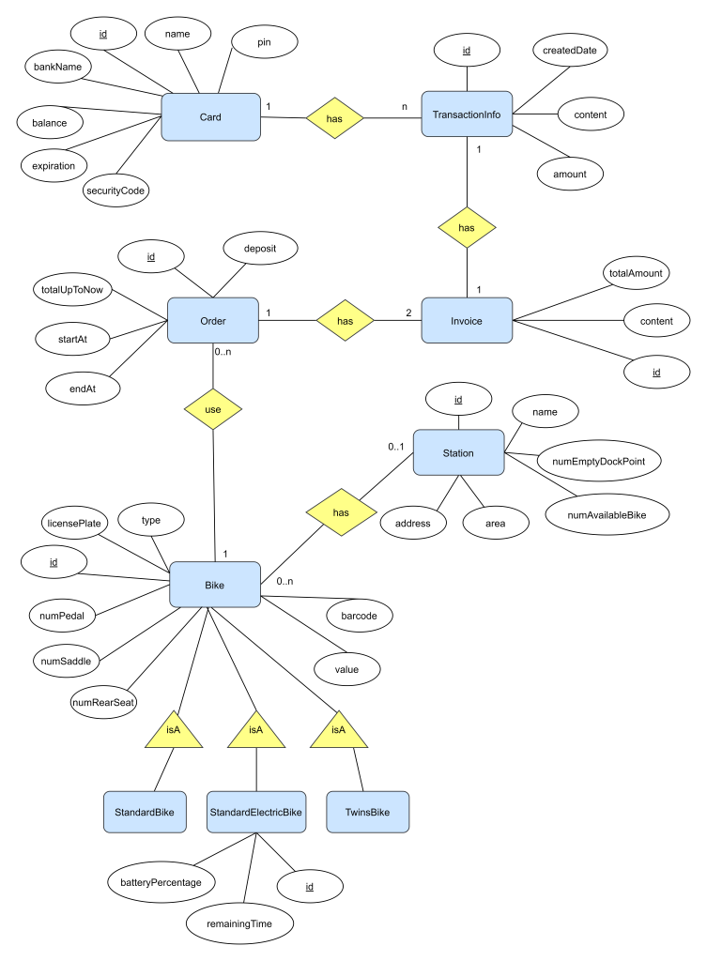

### Database Design

#### Database Management Systems

* Database Management System: MySql
* MySQLis the world's most popular open source database. With its proven performance, reliability and ease-of-use, MySQL has become the leading database choice for web-based applications, used by high profile web properties including Facebook, Twitter, YouTube, Yahoo! and many more.

#### Logical Data Model

<

* *Show the process to design database from E-R diagram*
* *Show the diagram of DB design*

*>*

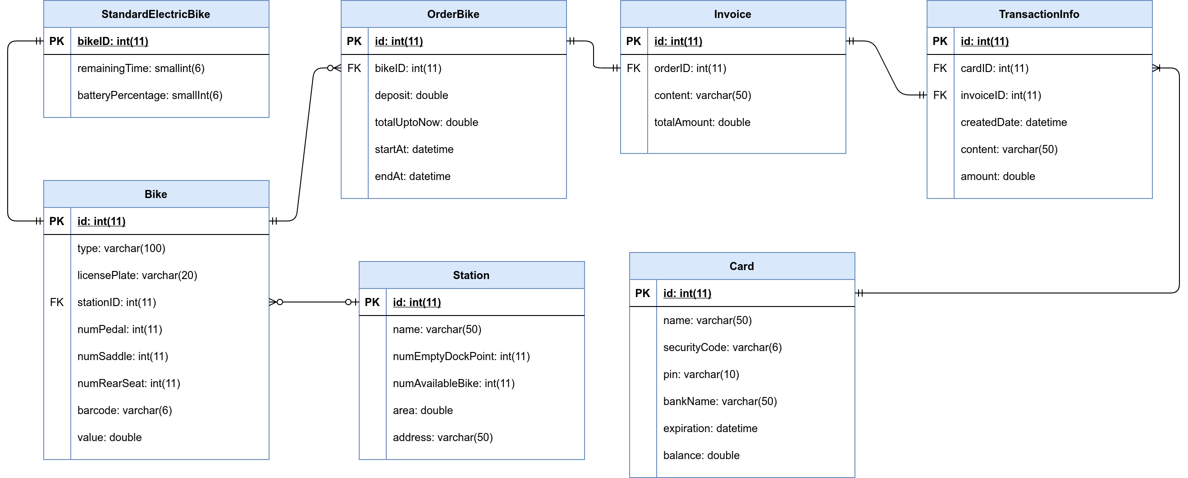

#### Physical Data Model

* **Card**

|  |  |  |  |  |  |  |
| --- | --- | --- | --- | --- | --- | --- |
| # | PK | FK | Column name | Data type | Mandatory | Description |
| 1 | x |  | id | Integer | Yes | ID of card,  auto increment |
| 2 |  |  | name | Varchar(50) | Yes | Name of Card’s holder |
| 3 |  |  | securityCode | Varchar(6) | Yes | Security code of card |
| 4 |  |  | pin | Varchar(10) | Yes | PIN number |
| 5 |  |  | bankName | Varchar(50) | Yes | Name of Interbank |
| 6 |  |  | expiration | datetime | Yes | Expiration date of card |
| 7 |  |  | balance | double | Yes | Balance of card |

* **TransactionInfo**

|  |  |  |  |  |  |  |
| --- | --- | --- | --- | --- | --- | --- |
| # | PK | FK | Column name | Data type | Mandatory | Description |
| 1 | x |  | id | Integer | Yes | ID of transaction,  auto increment |
| 2 |  |  | content | Varchar(50) | Yes | Content of transaction |
| 3 |  | x | cardID | Integer | Yes | cardID, same as ID of  card which is used for the transaction |
| 4 |  | x | invoiceID | Integer | Yes | invoiceID, same as ID of invoice which belongs to the transaction |
| 5 |  |  | createDate | datetime | Yes | Creation date of  the transaction |
| 6 |  |  | amount | double | Yes | Total amount of money is used for the transaction |

* **Station**

|  |  |  |  |  |  |  |
| --- | --- | --- | --- | --- | --- | --- |
| # | PK | FK | Column name | Data type | Mandatory | Description |
| 1 | x |  | id | Integer | Yes | ID of station,  auto increment |
| 2 |  |  | name | Varchar(50) | Yes | Name of the station |
| 3 |  |  | numEmptyDockPoint | Integer | Yes | Number of empty dock points in the station |
| 4 |  |  | numAvailableBike | Integer | Yes | Number of available bike for renting in the station |
| 5 |  |  | area | double | Yes | Area of the station |
| 6 |  |  | address | varchar(50) | Yes | Address of the station |

* **Bike**

|  |  |  |  |  |  |  |
| --- | --- | --- | --- | --- | --- | --- |
| # | PK | FK | Column name | Data type | Mandatory | Description |
| 1 | x |  | id | Integer | Yes | id of the bike , auto increment |
| 2 |  |  | type | Varchar(50) | Yes | type of bike |
| 3 |  |  | licensePlate | Varchar(6) | Yes | license plate of the bike |
| 4 |  |  | numPedal | Integer | Yes | numbers of pedal |
| 5 |  |  | numSaddle | Integer | Yes | numbers of saddle of the bike |
| 6 |  |  | numRearSeat | Integer | Yes | numbers of rear seat |
| 7 |  |  | value | Integer | Yes | value of the bike |
| 8 |  |  | Barcode | Varchar(6) | Yes | Barcode of the bike |

* **StandardElectricBike**

|  |  |  |  |  |  |  |
| --- | --- | --- | --- | --- | --- | --- |
| # | PK | FK | Column name | Data type | Mandatory | Description |
| 1 | x | X | id | Integer | Yes | id of the bike |
| 2 |  |  | batteryPercentage | Integer | Yes | percentage of battery |
| 3 |  | x | remainingTime | Integer | Yes | remaining time of the bike |

* **Order**

|  |  |  |  |  |  |  |
| --- | --- | --- | --- | --- | --- | --- |
| # | PK | FK | Column name | Data type | Mandatory | Description |
| 1 | x |  | id | Integer | Yes | ID of order,  auto increment |
| 2 |  |  | deposit | double | Yes | Amount of deposit  when renting bike |
| 3 |  |  | startAt | datetime | Yes | When user rents bike |
| 4 |  |  | endAt | datetime | No | When the user returns  bike |
| 5 |  |  | totalUpToNow | double | No | The amount of renting  money (not include  deposit) |
| 6 |  | x | bikeID | integer | Yes | The id of the bike that  user is/was renting |

* **Invoice**

|  |  |  |  |  |  |  |
| --- | --- | --- | --- | --- | --- | --- |
| # | PK | FK | Column name | Data type | Mandatory | Description |
| 1 | x |  | id | Integer | Yes | ID of the invoice,  auto increment |
| 2 |  |  | content | Varchar(50) | Yes | The content of the  Invoice |
| 3 |  |  | totalAmount | double | Yes | The amount of money  for the transaction |
| 4 |  | x | orderID | Integer | Yes | The Order of which  this invoice is used for |

* **Database Script:**

CREATE TABLE Card(

id INT AUTO_INCREMENT PRIMARY KEY,

NAME VARCHAR(50) not null,

securityCode VARCHAR(6) not null,

pin VARCHAR(10) not null,

bankName VARCHAR(50) not null,

expiration DATETIME not null,

balance DOUBLE not null

);

CREATE TABLE Order (

id INT AUTO_INCREMENT PRIMARY KEY,

deposit double not null,

totalUpToNow DOUBLE,

bikeID int not null,

startAt DATETIME not null,

endAt DATETIME,

FOREIGN KEY bikeID REFERENCES Bike(id)

);

CREATE TABLE Invoice(

id INT AUTO_INCREMENT PRIMARY KEY,

content VARCHAR(50) not null,

totalAmount DOUBLE not null,

orderID int not null,

FOREIGN KEY orderID REFERENCES Order(id)

);

CREATE TABLE TransactionInfo(

id INT AUTO_INCREMENT PRIMARY KEY,

cardID INT,

invoiceID INT,

createdDate DATETIME,

content VARCHAR(50),

amount DOUBLE,

FOREIGN KEY cardID REFERENCES Card(id),

FOREIGN KEY invoiceID REFERENCES Invoice(id)

);

CREATE TABLE Station(

id INT AUTO_INCREMENT PRIMARY KEY,

name VARCHAR(50) not null,

numEmptyDockPoint INT not null,

numAvailableBike INT not null,

area DOUBLE not null,

address VARCHAR(50) not null

);

create table Bike (

type varchar(100),

licensePlate varchar(20),

id int AUTO_INCREMENT PRIMARY key,

stationID int ,

numPedal int ,

numSaddle int ,

numRearSeat int ,

barcode varchar(6) not null,

value double not null,

FOREIGN key stationID REFERENCES Station(id)

)

create table StandardElectricBike(

id int primary key,

batteryPercentage int(2) ,

remainingTime double,

foreign key id references Bike(id)

*)*

## Non-Database Management System Files

## Class Design

### General Class Diagram

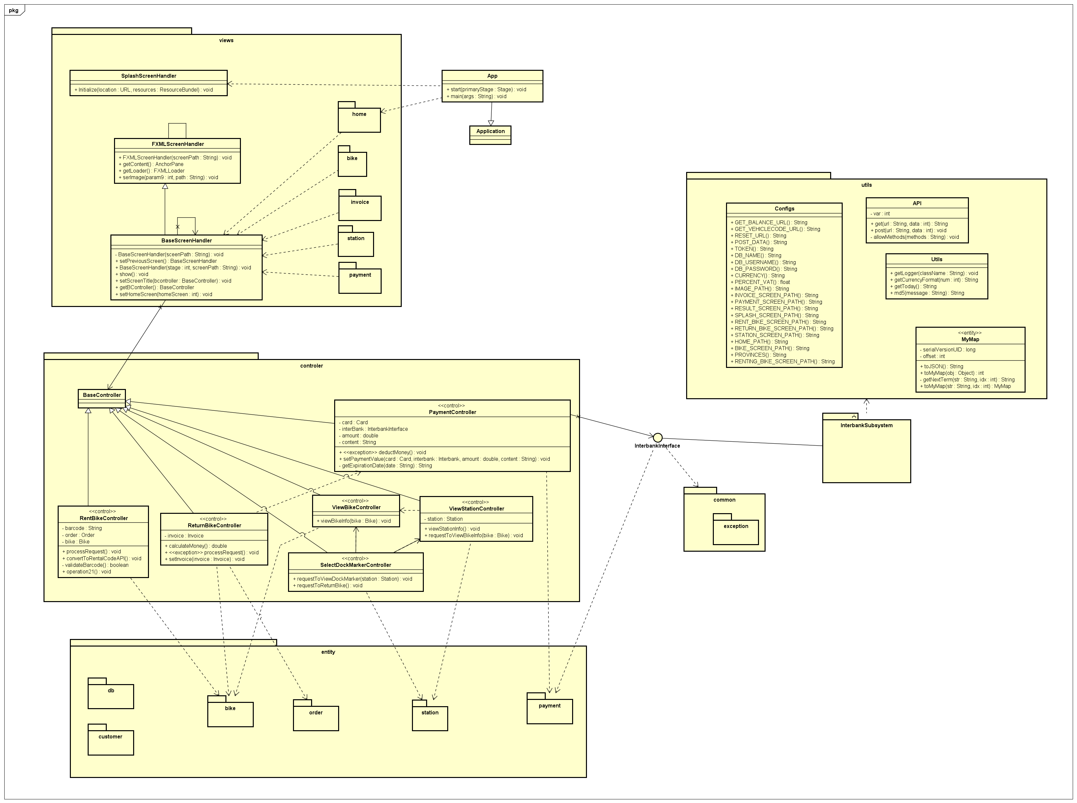

### Class Diagrams

#### Class Diagram for Package A

**...**

#### Class Diagram for Interbank Subsystem

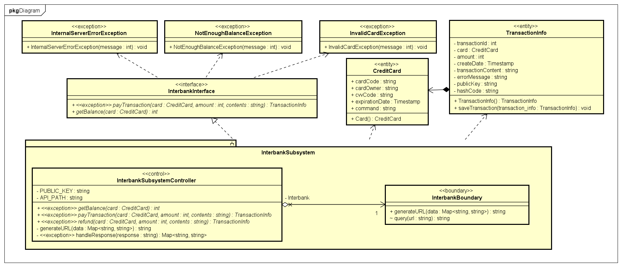

### Class Design

#### Class “PaymentController”

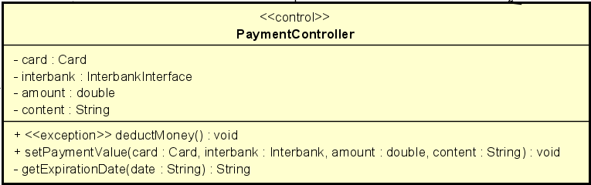

***Attribute***

|  |  |  |  |  |
| --- | --- | --- | --- | --- |
| # | Name | Data type | Default value | Description |
| 1 | card | Card | NULL | Represent the card used for payment |
| 2 | amount | double | NULL | Represent total amount of the transaction |
| 3 | content | String | NULL | Represent content of transaction |
| 4 | interbank | InterbankInterface | NULL | Represent the interbank |

***Operation***

|  |  |  |  |
| --- | --- | --- | --- |
| # | Name | Return type | Description (purpose) |
| 1 | deductMoney | void | Send request to interbank API to deduct money from card to pay for renting bike |
| 2 | setPaymentValue | void | Set value for all attributes of *PaymentController* class |

*Parameter*:

* card – the credit card used for payment
* interbank – interbank of transaction
* amount – total amount of transaction
* content – content of transaction

*Exception*:

* PaymentException: if responded with error that transaction is failed

***State :*** None

***Method***

* getExpirationDate: given the String “date” representing the expiration date in the format “”mm/yy”, this method converts it into the required format “mmyy”. The algorithm is illustrated as follows.
* 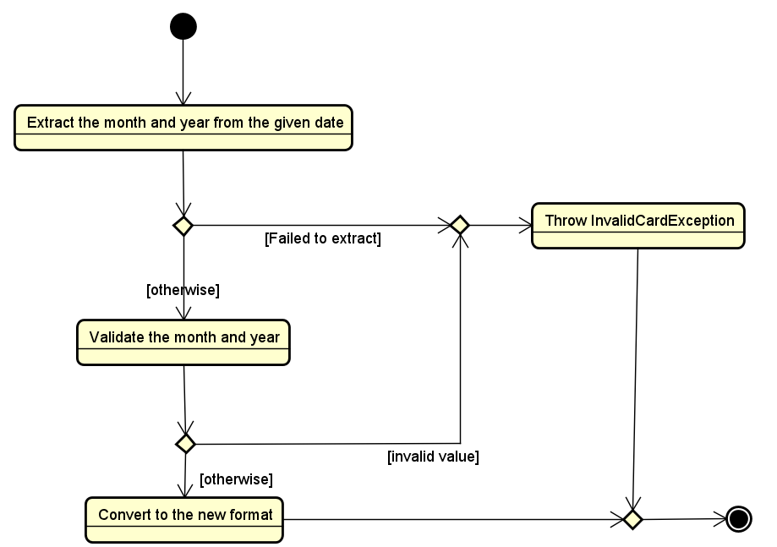

#### Class “TransactionInfo”

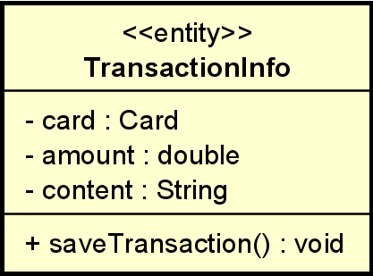

***Attribute***

|  |  |  |  |  |
| --- | --- | --- | --- | --- |
| # | Name | Data type | Default value | Description |
| 1 | card | Card | NULL | Represent the card used for payment |
| 2 | amount | double | NULL | Represent total amount of the transaction |
| 3 | content | String | NULL | Represent content of transaction |

***Operation***

|  |  |  |  |
| --- | --- | --- | --- |
| # | Name | Return type | Description (purpose) |
| 1 | saveTransaction | void | Save the transaction between software and interbank |

*Parameter*: None

*Exception*: None

***Method:*** None

***State:*** None

#### Class “ReturnBikeController”

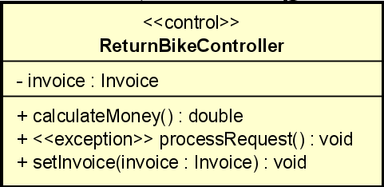

***Attribute***

|  |  |  |  |  |
| --- | --- | --- | --- | --- |
| # | Name | Data type | Default value | Description |
| 1 | invoice | Invoice | NULL | Represent invoice of returning bike |

***Operation***

|  |  |  |  |
| --- | --- | --- | --- |
| # | Name | Return type | Description (purpose) |
| 1 | calculateMoney | double | Calculate total amount that customer has to pay when return bike |
| 2 | processRequest | void | Process returning bike request, call *ReturnBikeHandler* and *InvoiceHandler* class |
| 3 | setInvoice | void | Set value for invoice after calculate money |

*Parameter*:

* Invoice – invoice of returning bike

*Exception*:

* ReturnBikeException: if responded with error that return bike request is failed

***State:*** None

***Method:*** None

#### Class “RentedBileInfoScreen”

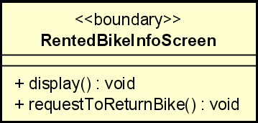

***Attribute***

***Operation***

|  |  |  |  |
| --- | --- | --- | --- |
| # | Name | Return type | Description (purpose) |
| 1 | display | void | Display detail of renting bike include amount up to now that customer has to pay |
| 2 | requestToReturnBike | void | Request to return bike |

*Parameter*: None

*Exception*: None

***Method*** None

***State*** None

#### Class “PaymentHandler”

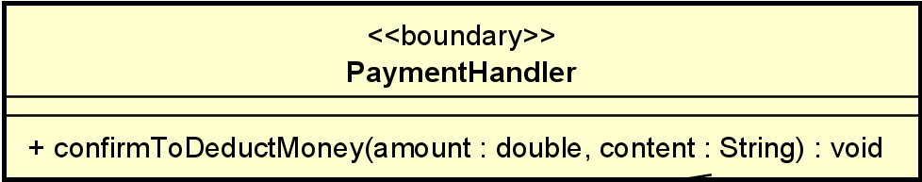

***Attribute***

***Operation***

|  |  |  |  |
| --- | --- | --- | --- |
| # | Name | Return type | Description (purpose) |
| 1 | confirmToDeductMoney | void | Confirm to deduct money from card to pay for renting bike |

*Parameter*:

* amount: total amount that interbank will deduct from customer’s card
* content: content of transaction

*Exception*: None

***Method*** None

***State*** None

#### Class “InterbankInterface”

***Attribute***

***Operation***

|  |  |  |  |
| --- | --- | --- | --- |
| # | Name | Return type | Description (purpose) |
| 1 | deductMoney | void | Confirm to deduct money from card to pay for renting bike |

*Parameter*:

* amount: total amount that interbank will deduct from customer’s card
* content: content of transaction
* card: the credit card used for payment

*Exception*:

* InterbankPaymentException: if responded with a pre-defined error code
* UnrecognizeException: if responded with an unknown error code or something goes wrong

***Method:*** None

***State:*** None

#### Class “ReturnBikeHandler”

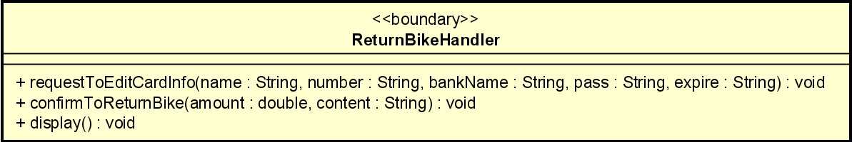

***Attribute***

***Operation***

|  |  |  |  |
| --- | --- | --- | --- |
| # | Name | Return type | Description (purpose) |
| 1 | requestToEditCardInfo | void | Edit card information |
| 2 | confirmToReturnBike | void | Confirm to return bike |
| 3 | display | void | Display detailed information of return bike and card information of customer |

*Parameter*:

* amount: total amount that customer has to pay for returning bike
* content: content of transaction
* name: card’s holder name
* number: card number
* bankName: name of interbank
* pass: security code of card
* expire: expiration date of card

*Exception*: None

***Method:*** None

***State:*** None

#### Class “ListDockToReturnHandler”

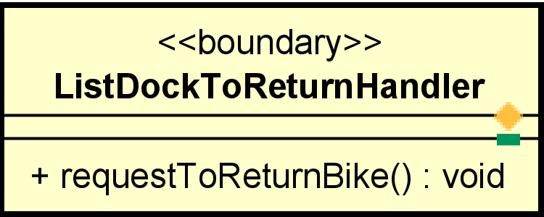

**Attribute**

**Operation**

|  |  |  |  |
| --- | --- | --- | --- |
| # | Name | Return type | Description (purpose) |
| 1 | requestToReturnBike | void | Request to return bike, call selectDockMakerController |

*Parameter*: None

*Exception*: None

**Method:** none

**State:** none

#### Class “ViewBikeController”

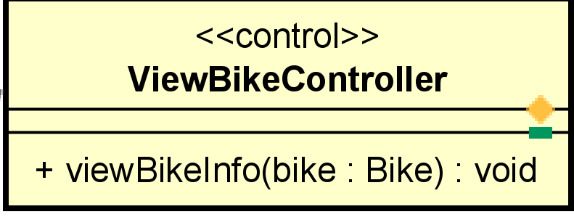

**Attribute**

**Operation**

|  |  |  |  |
| --- | --- | --- | --- |
| # | Name | Return type | Description (purpose) |
| 1 | viewBikeInfo | void | Process request view specific bike info |

*Parameter*

* bike: bike that want to view information

*Exception*: ViewBikeException

**Method:** none

**State:** none

#### Class “BikeInformationHandler”

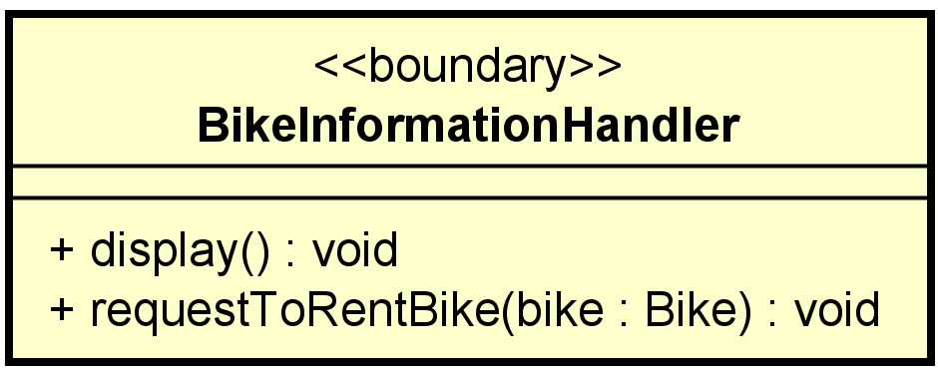

**Attribute**

**Operation**

|  |  |  |  |
| --- | --- | --- | --- |
| # | Name | Return type | Description (purpose) |
| 1 | display | void | Display bike information |
| 2 | requestToRentBike | Void | When user submit to rent bike, sent request to rentBikeController |

*Parameter*

* bike: bike that user want to rent

**Method:** none

**State:** none

#### Class“Bike”

**Attribute**

|  |  |  |  |  |
| --- | --- | --- | --- | --- |
| # | Name | Data type | Default value | Description |
| 1 | numSaddle | int | NULL | Number saddle of the bike |
| 2 | numPedal | int | NULL | Number pedal of the bike |
| 3 | numRearSeat | Int | NULL | Number rear seat of the bike |
| 4 | licensePlate | String | NULL | Represent license plate of the bike |
| 5 | value | double | NULL | Represent value of the bike |
| 6 | barcode | String | NULL | Represent barcode of the bike |
| 7 | type | String | NULL | Represent type of the bike |
| 8 | station | Station | NULL | Represent bike in which station |

**Operation**

|  |  |  |  |
| --- | --- | --- | --- |
| # | Name | Return type | Description (purpose) |
| 1 | getBikeInfo | void | Get bike information for display |
| 2 | setBikeInfo | void | Set bike information |
| 3 | Bike | void | Constructor |
| 4 | getter | void | Get all attribute in acronym |
| 5 | setter | void | Set value for each attribute in acronym |

*Parameter*: same like attribute

**Method:** none

**State:**

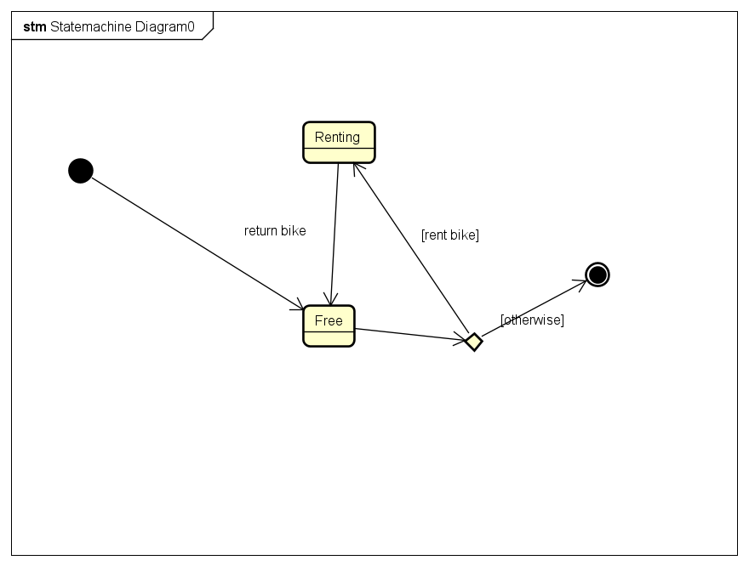

#### Class “StandardElectricBike”

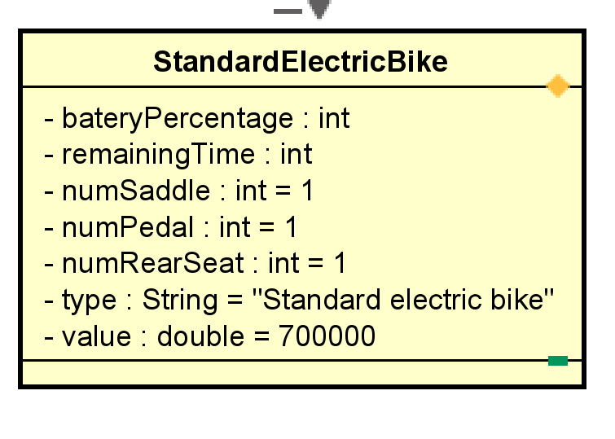

**Attribute**

|  |  |  |  |  |
| --- | --- | --- | --- | --- |
| # | Name | Data type | Default value | Description |
| 1 | numSaddle | int | 1 | Unchanged value |
| 2 | numPedal | int | 1 | Constant value |
| 3 | numRearSeat | int | 1 | Constant value |
| 4 | value | double | 700000 | Constant value |
| 5 | type | String | “Standard electric bike” | Constant type |

**Operation:** inherit

**Method:** none

**State:** none

#### Class “StandardBike”

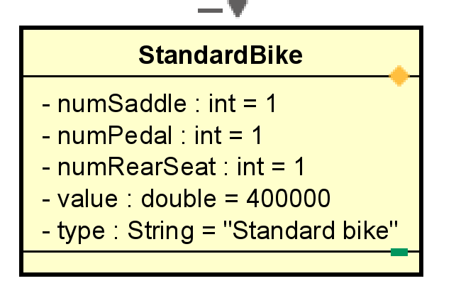

***Attribute***

|  |  |  |  |  |
| --- | --- | --- | --- | --- |
| # | Name | Data type | Default value | Description |
| 1 | numSaddle | int | 1 | Unchanged value |
| 2 | numPedal | int | 1 | Constant value |
| 3 | numRearSeat | int | 1 | Constant value |
| 4 | value | double | 400000 | Constant value |
| 5 | type | String | “Standard bike” | Constant type |

**Operation:** inherit

**Method:** none

**State:** none

#### Class “TwinBike”

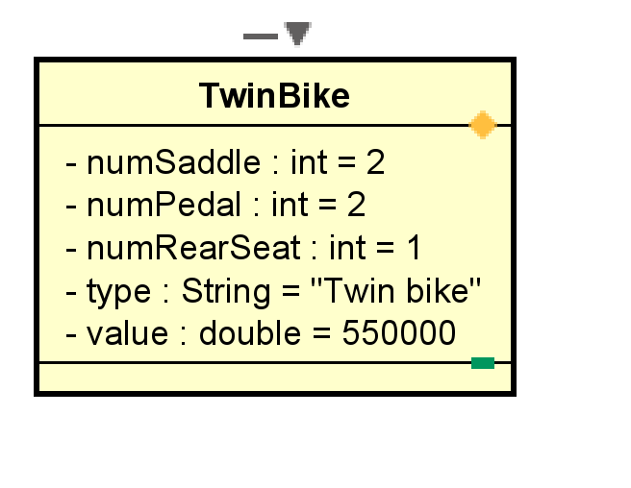

***Attribute***

|  |  |  |  |  |
| --- | --- | --- | --- | --- |
| # | Name | Data type | Default value | Description |
| 1 | numSaddle | int | 2 | Unchanged value |
| 2 | numPedal | int | 2 | Constant value |
| 3 | numRearSeat | int | 1 | Constant value |
| 4 | value | double | 550000 | Constant value |
| 5 | type | String | “Twin bike” | Constant type |

**Operation:** inherit

**Method:** none

**State:** none

#### Class “SelectDockMarkerController”

**Attribute**

**Operation**

|  |  |  |  |
| --- | --- | --- | --- |
| # | Name | Return type | Description (purpose) |
| 1 | requestToViewDockMarker | void | Process request to view the dock marker |
| 2 | RequestToReturnBike | void | Process to request to return the bike |

*Parameter*

* station: station that want to view information

*Exception*: ViewStationException

**Method:** none

**State:** none

#### Class “ViewStationController”

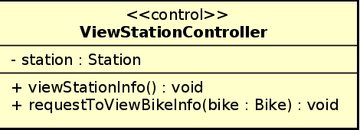

**Attribute** station: station that user want to view information

**Operation**

|  |  |  |  |
| --- | --- | --- | --- |
| # | Name | Return type | Description (purpose) |
| 1 | viewStationInfo | void | View station information |
| 2 | requestToViewBikeInfo | Void | Process to request to view bike information |

*Parameter*

* bike: bike that user want to rent

**Method:** none

**State:** none

#### Class “ListDockForViewHandler”

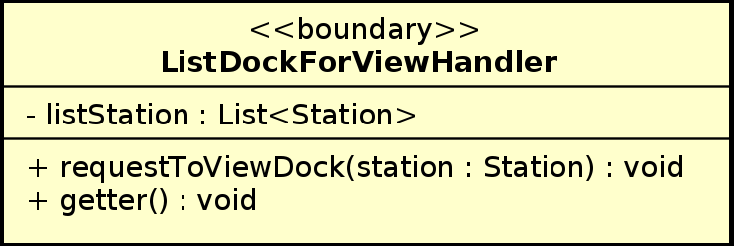

**Attribute** listStation: a list of stations

**Operation**

|  |  |  |  |
| --- | --- | --- | --- |
| # | Name | Return type | Description (purpose) |
| 1 | requestToViewDock | void | Process to request to view dock |
| 2 | getter | Void | get method |

*Parameter*

* station: station that user want to view information

**Method:** none

**State:** none

#### Class “StationInfoHandler”

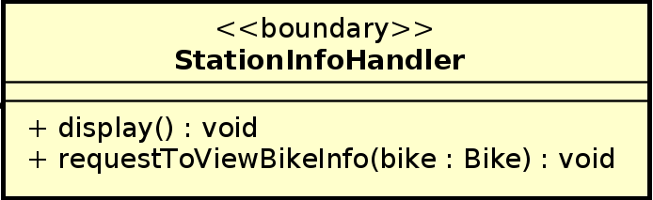

**Attribute**

**Operation**

|  |  |  |  |
| --- | --- | --- | --- |
| # | Name | Return type | Description (purpose) |
| 1 | display | void | Display station information |
| 2 | requestToViewBikeInfo | Void | Process to request to view bike information |

*Parameter*

* bike: bike that user want to view information

**Method:** none

**State:** none

#### Class “ListBikeHandler”

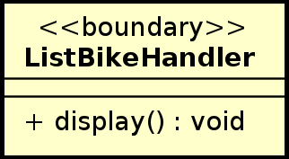

**Attribute**

**Operation**

|  |  |  |  |
| --- | --- | --- | --- |
| # | Name | Return type | Description (purpose) |
| 1 | display | void | Display list of bikes |

*Parameter:* none

**Method:** none

**State:** none

#### Class “Station”

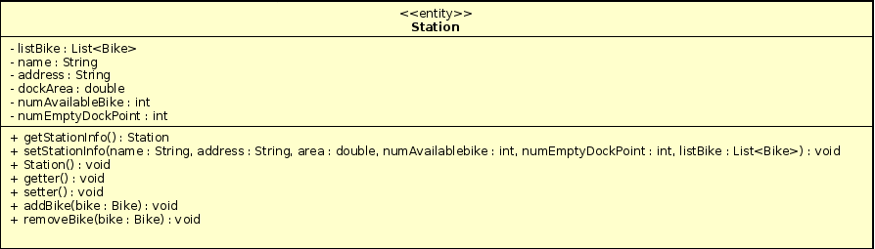

**Attribute**

|  |  |  |  |  |
| --- | --- | --- | --- | --- |
| # | Name | Data type | Default value | Description |
| 1 | listBike | List<Bike> | NULL | List the bikes in the station |
| 2 | name | String | NULL | Name of the station |
| 3 | address | String | NULL | Address of the station |
| 4 | dockArea | double | NULL | Area of the dock |
| 5 | numAvailableBike | int | NULL | Number of available bikes |
| 6 | numEmptyDockPoint | int | NULL | Number of empty dock points |

**Operation**

|  |  |  |  |
| --- | --- | --- | --- |
| # | Name | Return type | Description (purpose) |
| 1 | getStationInfo | Station | Get station information for display |
| 2 | setStationInfo | void | Set station information |
| 3 | Station | void | Constructor |
| 4 | getter | void | Get all attribute in acronym |
| 5 | setter | void | Set value for each attribute in acronym |
| 6 | addBike | void | Add bike to the station if user return bike |
| 7 | removeBike | void | Remove bike in the station if user rent bike |

*Parameter*: same like attribute

**Method:** none

**State:** none

#### Class “Card”

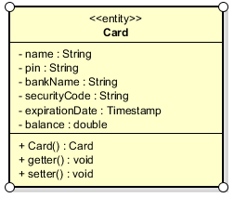

***Attribute***

|  |  |  |  |  |
| --- | --- | --- | --- | --- |
| # | Name | Data type | Default value | Description |
| 1 | name | String | NULL | Name of the owner of the credit card |
| 2 | pin | String | NULL | Pin code of the credit card |
| 3 | bankName | String | NULL | The name of the bank that provides the credit card |
| 4 | securityCode | String | NULL | Security code of the credit card |
| 5 | expirationDate | Timestamp | NULL | The expiration date of the card, in form MM/YYYY |
| 6 | Balance | double | 0.00 | The balance of the card |

***Operation***

|  |  |  |  |
| --- | --- | --- | --- |
| # | Name | Return type | Description (purpose) |
| 1 | Card | Card | Constructor |
| 2 | getter | void | Get all attribute in acronym |
| 3 | setter | void | Set value for each attribute in acronym |

*Parameter:* same as attributes

***State:*** None

***Method:*** None

#### Class “InvoiceHandler”

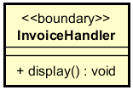

***Attribute***

***Operation***

|  |  |  |  |
| --- | --- | --- | --- |
| # | Name | Return type | Description (purpose) |
| 1 | display | void | Display the invoice screen |

***State:*** None

***Method:*** None

#### Class “Invoice”

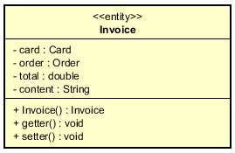

***Attribute***

|  |  |  |  |  |
| --- | --- | --- | --- | --- |
| # | Name | Data type | Default value | Description |
| 1 | card | Card | NULL | The credit card that was used for this transaction/invoice |
| 2 | order | Order | NULL | The order that was used for this transaction/invoice |
| 3 | total | double | 0.00 | The amount of money that was transferred in the transaction/The amount of money that was deducted from the credit card in the transaction |
| 4 | content | String | NULL | The details of the transaction/invoice |

***Operation***

|  |  |  |  |
| --- | --- | --- | --- |
| # | Name | Return type | Description (purpose) |
| 1 | Invoice | Invoice | Constructor |
| 2 | getter | void | Get all attribute in acronym |
| 3 | setter | void | Set value for each attribute in acronym |

*Parameter*: same as attributes

***State:*** None

***Method:*** None

#### Class “Order”

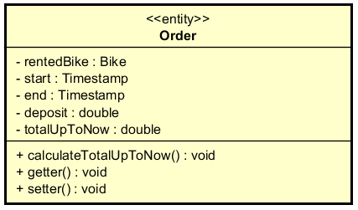

***Attribute***

|  |  |  |  |  |
| --- | --- | --- | --- | --- |
| # | Name | Data type | Default value | Description |
| 1 | rentedBike | Bike | NULL | The bike that was rented by user |
| 2 | start | Timestamp | Time when the bike was rented | The timestamp which user rented the bike |
| 3 | end | Timestamp | Current Time | The timestamp which user returns bike (in case this order is for returning bike), or current time (in case this order is for renting bike) |
| 4 | deposit | double | 0.00 | The deposit when renting the bike |
| 5 | totalUpToNow | double | 0.00 | Total renting money up to now (not include deposit) |

***Operation***

|  |  |  |  |
| --- | --- | --- | --- |
| # | Name | Return type | Description (purpose) |
| 1 | calculateTotalUpToNow | void | Calculate the renting amount up to now (not include deposit) |
| 2 | getter | void | Get all attribute in acronym |
| 3 | setter | void | Set value for each attribute in acronym |

*Parameter*: same as attributes

***State:*** None

***Method:*** None

#### Class “RentBikeController”

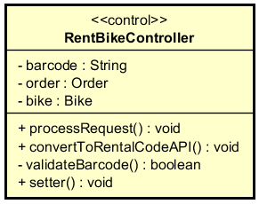

***Attribute***

|  |  |  |  |  |
| --- | --- | --- | --- | --- |
| # | Name | Data type | Default value | Description |
| 1 | barcode | String | NULL | The barcode of the rented bike |
| 2 | order | Order | NULL | The order is made when renting bike |
| 3 | bike | Bike | NULL | The rented bike |

***Operation***

|  |  |  |  |
| --- | --- | --- | --- |
| # | Name | Return type | Description (purpose) |
| 1 | processRequest | void | Process the request of renting bike, to see that if the request comes from user entering the barcode or user choosing the bike |
| 2 | validateBarcode | boolean | In case the user entering the barcode (the barcode attribute is not empty), then we should check if the barcode is valid. If it is, call the setter of the bike attribute. If it is not, an error is displayed in the barcode screen. |
| 3 | convertToRentalCodeAPI | void | Call the API to convert the barcode into rental code |
| 4 | setter | void | Set value for each attribute in acronym |

*Parameter*

*Exception:*

* RentBikeException: if responded with error that rent bike request is failed

***State:*** None

***Method:*** None

#### Class “RentBikeHandler”

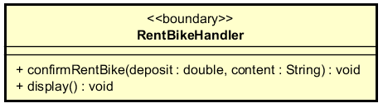

***Attribute***

***Operation***

|  |  |  |  |
| --- | --- | --- | --- |
| # | Name | Return type | Description (purpose) |
| 1 | display | void | Display the rent bike screen |
| 2 | confirmRentBike | void | Display the payment screen, send the deposit amount and the transaction content to the payment controller |

*Parameter:*

* deposit - the deposit amount that user has to pay when renting bike
* content - the details of the transaction when sending to payment

***State:*** None

***Method:*** None

#### Class “BarCodeHandler”

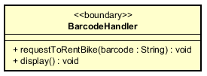

***Attribute***

***Operation***

|  |  |  |  |
| --- | --- | --- | --- |
| # | Name | Return type | Description (purpose) |
| 1 | display | void | Display the barcode screen |
| 2 | requestToRentBike | void | After the user inputs the barcode, this function sends the barcode to controller to process the rent-bike request |

*Parameter*:

* barcode: the code that user inputs when he/she wants to rent bike

***State:*** None

***Method:*** None

# Design Considerations

## Goals and Guidelines

**Goals:**

* Bring a good looking and good experience for users
* The response time for the system is 1 second at normal and 2 seconds during a peak load

**Guidelines**

* Observe java convention in coding, OOP principles
* Avoid hash code
* Explain code, write java doc for maintenance

## Architectural Strategies

Our design decisions focus on reusing components, unified system following

+ Programing Language: java

+ Database: MySQL

+ Unified on error detection and recovery

We always toward save memory and spaces, also speed up response time and nice looking. In the future, we plan to extend software: have site for admin to add, delete bike, statistics, business strategies. These targets make us concentrate totally on architectural design.

## Coupling and Cohesion

## Design Principles

We design simple classes that means a class should have only one job, one responsibility. Object or entities are open for extension but close for modification. We also use interfaces, abstract classes. We put all class with same properties into one package to manage easily. Therefore, we can reuse source code, adapt any changing requirements.

## Design Patterns

We don’t use any design patterns .